

UNIVERSITY OF ASIA PACIFIC

**Department of Computer Science & Engineering**

**LAB ASSIGNMENT-01**

**Course Title :** Microprocessors and Assembly LanguageLab

**Course Code :** CSE 312

**Date of Submission:** 14/09/2022

**Submitted by: Submitted To: Name :** Sheikh Nafez Sadnan Faria Zarin Subah **Reg. No. :** 20101106 Lecturer

**Roll No. :** 106 Department of CSE

**Section :** B (2) University of Asia Pacific

**Problem Statement 1:**

Perform the following operations using emu8086:

1. Declare the following variables assigning the stated values:

**Table1:**

|  |  |  |
| --- | --- | --- |
| Variable_name | Variable_size | Value_assigned |
| NUMB | DB | 01111000B |
| NUMD | DB | 120D |
| NUMO | DB | 170O |
| NUMH | DB | 78H |
| CHAR | DB | ‘3’ |
| CHARASC | DB | 3 |
| STR | DB | “HELLO WORLD” |
| UNKNOWN | DB | ? |

1. Take any character as input and assign that character as the value of the UNKNOWN variable.
2. Print the values of all 8 variables with a newline between each print statement. Provide a screenshot of your output screen.
3. Provide a screenshot showing the status of the variables after emulating your code.
4. State the reason why each output shown on the output screen of emu8086 is different from that of **Table1** ? Provide justification for each of the 8 variables.

**Screenshot of the assembly code:**

Line (1-34)

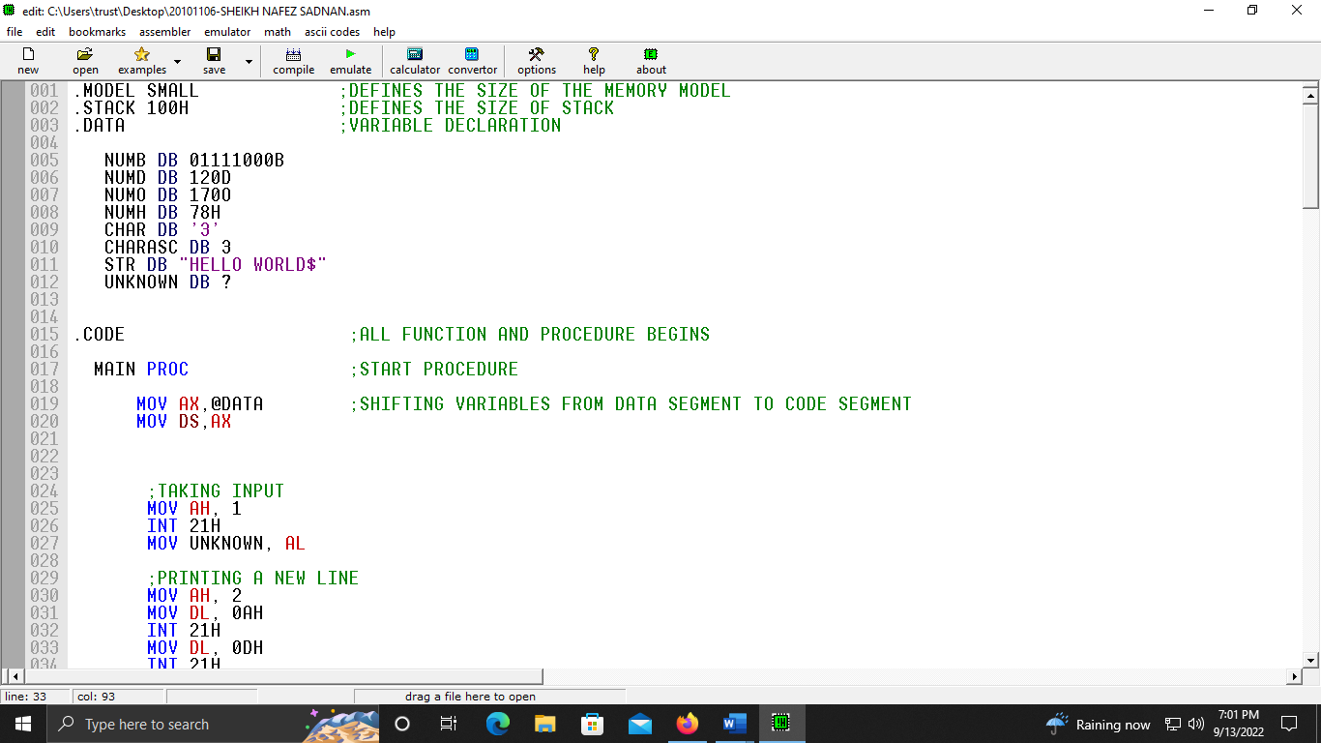

Line (34-67)

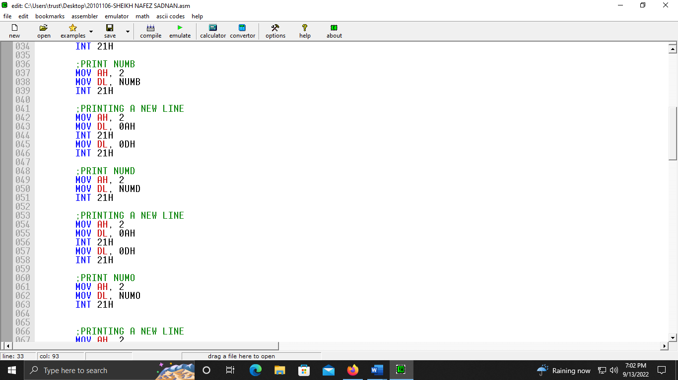

Line (67-100)

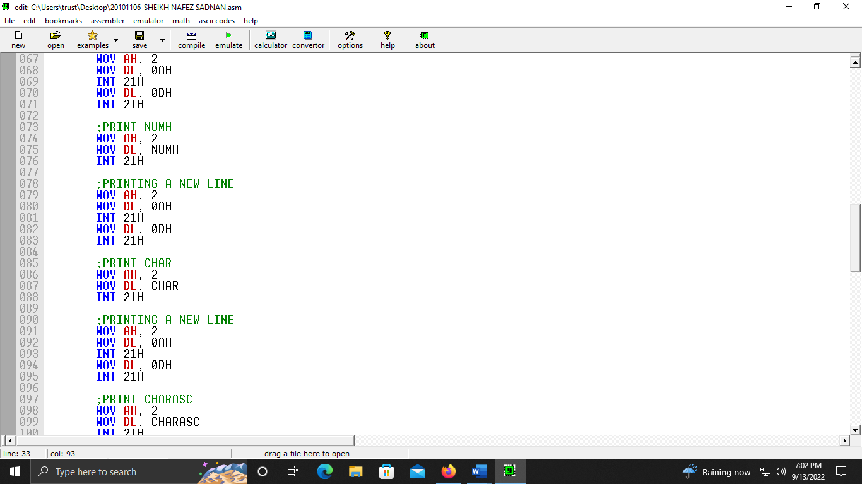

Line (100-133)

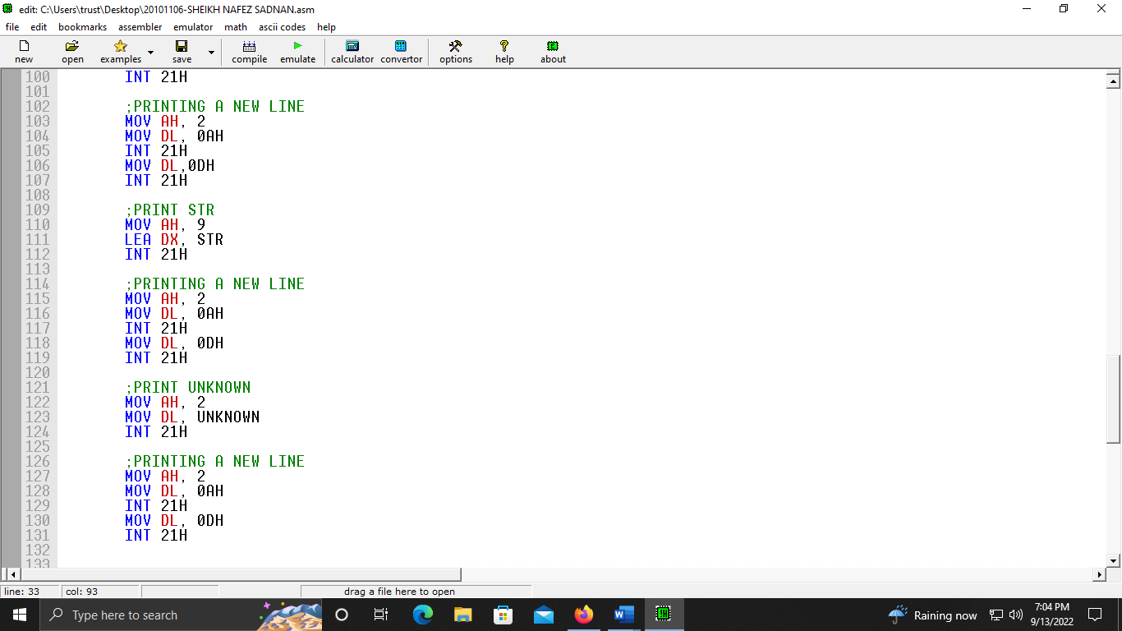

Line (121-140)

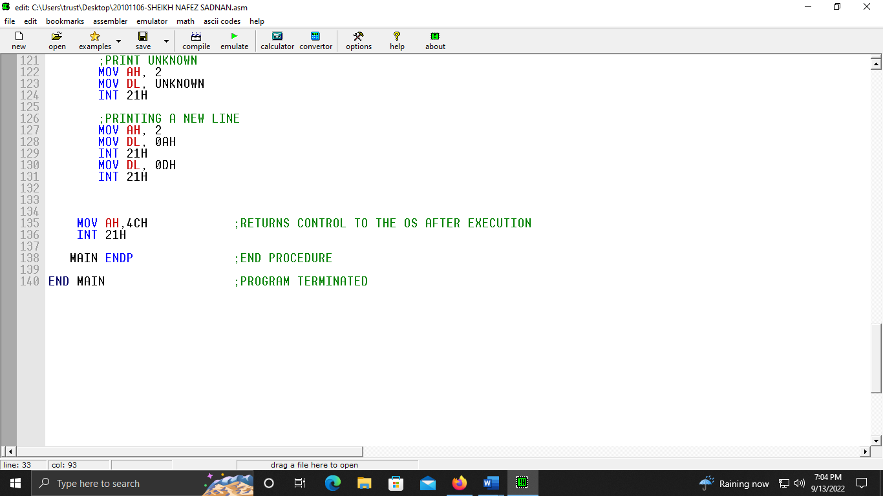

**Assembly Code Screen Shot (While Emulating):**

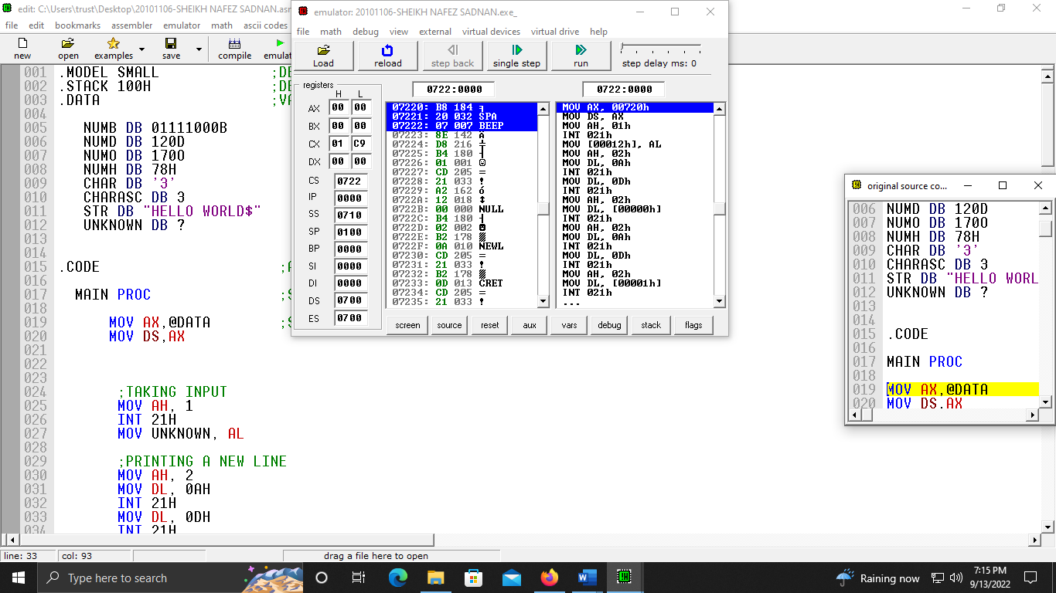

**Status of all 8 variables after assigning values:**

**NUMB DB 01111000B:**

After, assigning NUMB DB 01111000B,

AH got 02 (Calling the output subroutine)

DL got 78H (Equivalent to 01111000B)

Output is x which is different from Table-1

Because, in ASCII table **120:x** (01111000B/78H equivalent to 120 in decimal.)

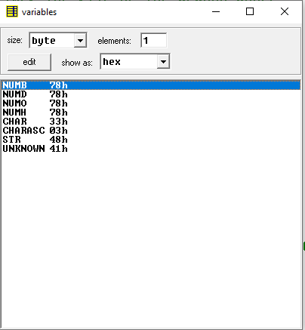

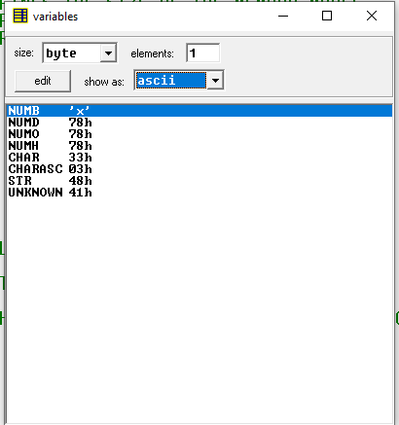

**NUMD DB 120D:**

After, assigning NUMD DB 120D,

AH got 02 (Calling the output subroutine)

DL got 78H (Equivalent to 120D)

Output is x which is different from Table-1

Because, in ASCII table **120:x** (78H equivalent to 120 in decimal.)

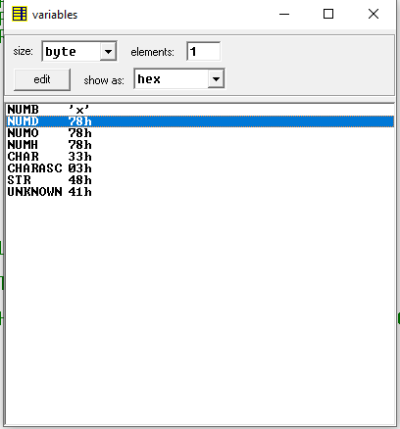

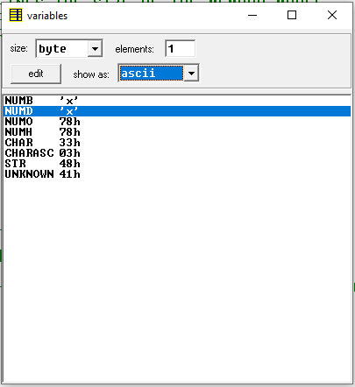

**NUMO DB 170O:**

After, assigning NUMO DB 170O,

AH got 02 (Calling the output subroutine)

DL got 78H (Equivalent to 170O)

Output is x which is different from Table-1

Because, in ASCII table **120:x** (170O/78H equivalent to 120 in decimal.)

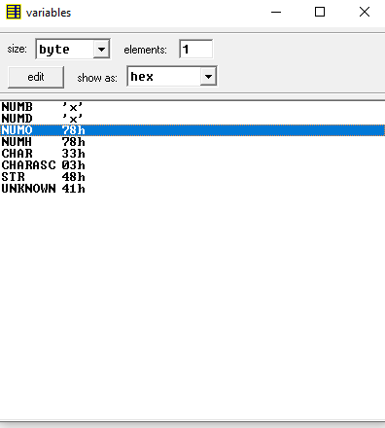

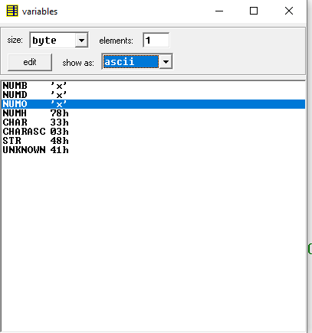

**NUMH DB 78H:**

After, assigning NUMH DB 78H,

AH got 02 (Calling the output subroutine)

DL got 78H

Output is x which is different from Table-1

Because, in ASCII table **120:x** (78H equivalent to 120 in decimal.)

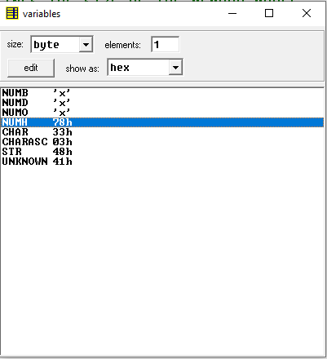

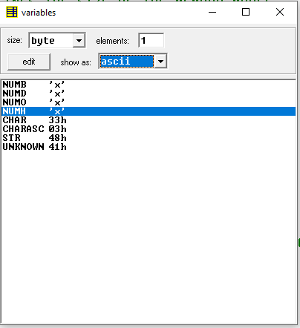

**CHAR DB '3':**

After, assigning CHAR DB ‘3’,

AH got 02 (Calling the output subroutine)

DL got 33H

Output is 3 which is different from Table-1

Because, in ASCII table **051:3** (33H equivalent to 051 in decimal.)

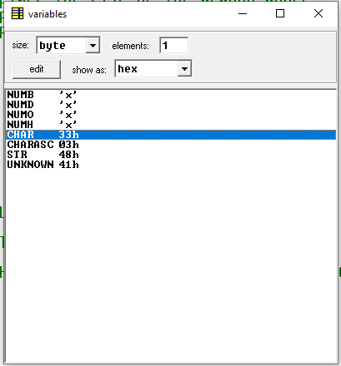

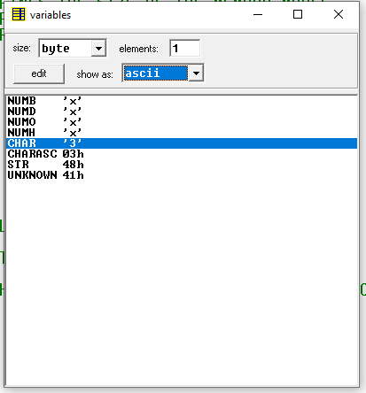

**CHARASC DB 3:**

After, assigning CHARASC DB 3,

AH got 02 (Calling the output subroutine)

DL got 03H

Output is a heart shape emoji which is different from Table-1

Because, in ASCII table **003:** ❤ (03H equivalent to 003 in decimal.)

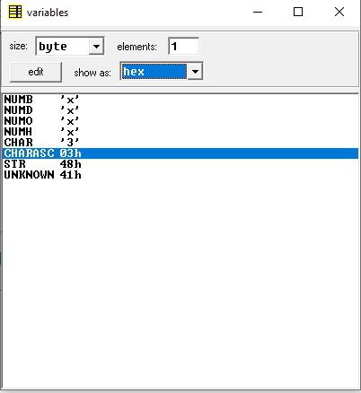

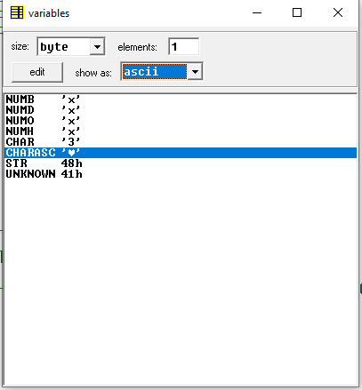

**STR DB "HELLO WORLD":**

Input needs a dollar ($) sign after the string.

Input- STR DB "HELLO WORLD$"

After, assigning STR DB “HELLO WORLD$”,

AH got 09 (Display string function)

Output is HELLO WORLD which is different from Table-1

Because, LEA DX, STR receives the string and INT 21H displays it.

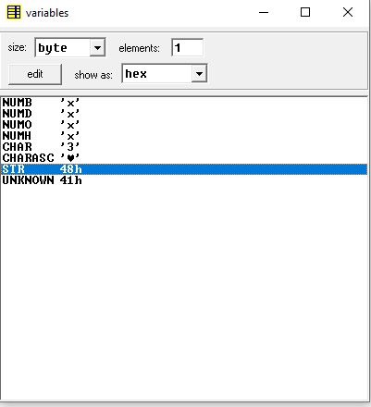

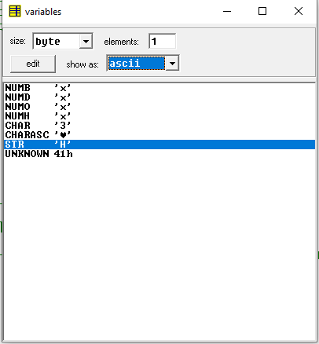

**UNKNOWN DB ? :**

After, assigning UNKNOWN DB ?,

AH got 02 (Calling the output subroutine)

DL got 41H

Output is A which was given as input, which is different from Table-1

Because, in ASCII table **065:A** (41H equivalent to 065 in decimal.)

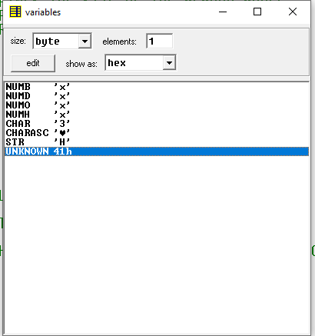

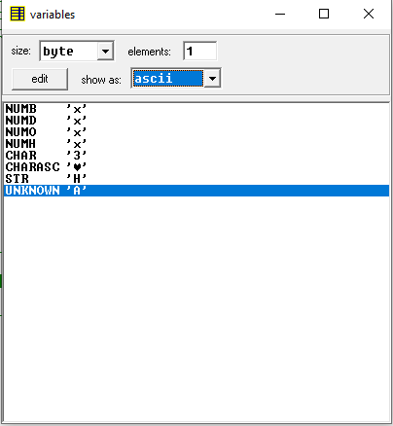

**A screenshot of the output screen:**

After all values are assigned, output displays on screen:

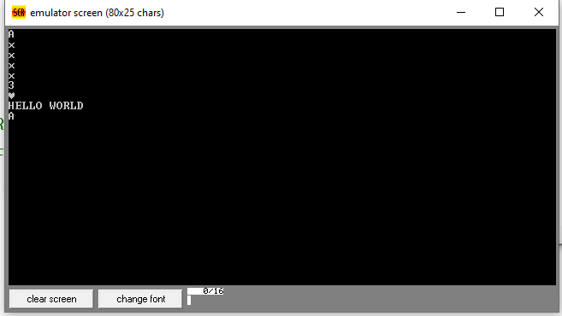

Here,

A (Given Input)

x (Output of 01111000B)

x (Output of 120D)

x (Output of 170O)

x (Output of 78H)

3 (Output of '3')

❤ (Output of 3)

HELLO WORLD (Output of ‘HELLO WORLD’)

A (Output of given Input)

**Reference:** The ASCII code table-

